- Association Between Neutrophil Levels and Frequent Headache:
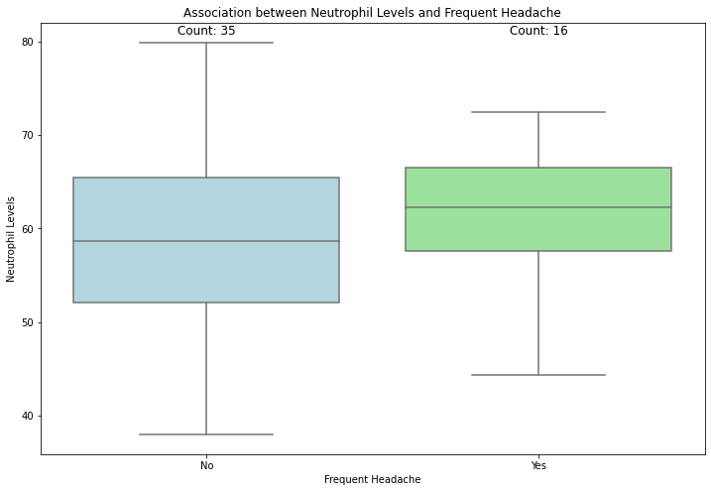
- Association Between Lymphocyte Levels and Frequent Headache:
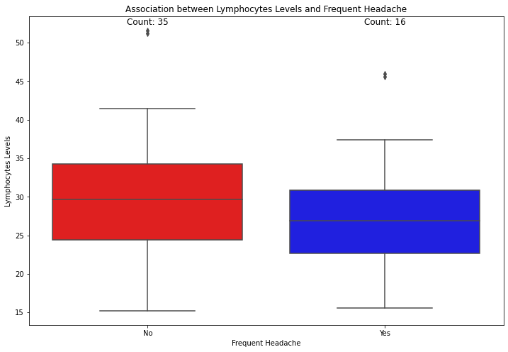
- Correlation Between Neutrophils/Lymphocytes Parameter& PASC Cases Neurological Symptoms:
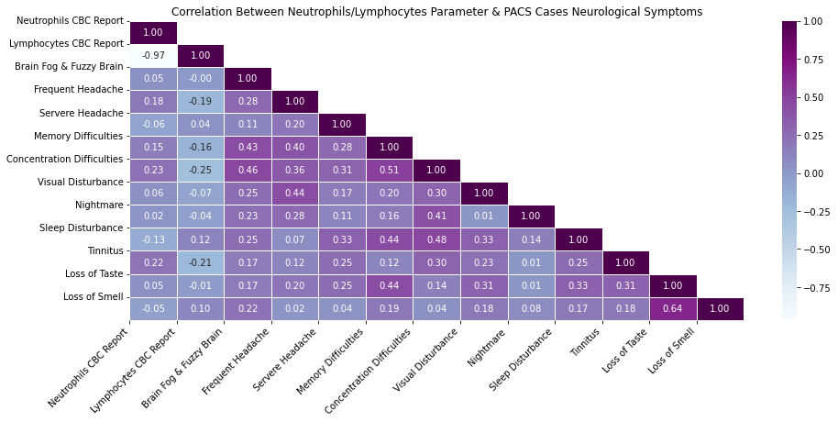 4. Correlation Between Neutrophils/Lymphocytes Parameter & PASC Cases General Symptoms:
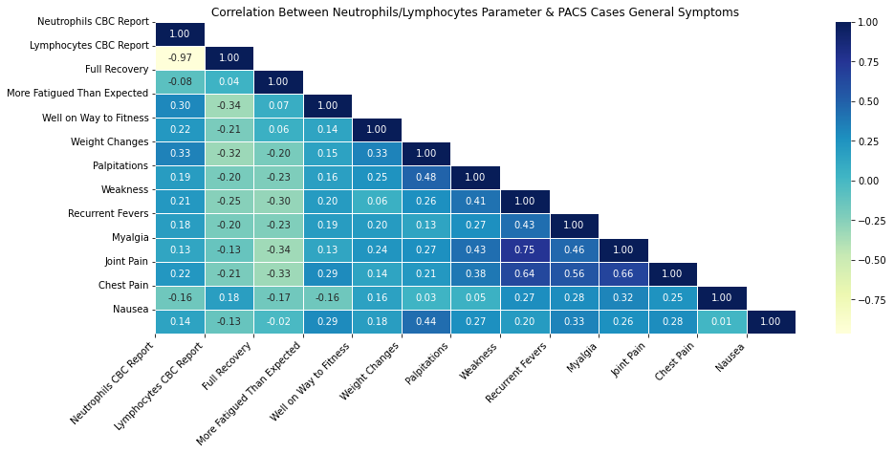
4. Correlation Between Neutrophils/Lymphocytes Parameter & PASC Cases Weakness Symptoms:
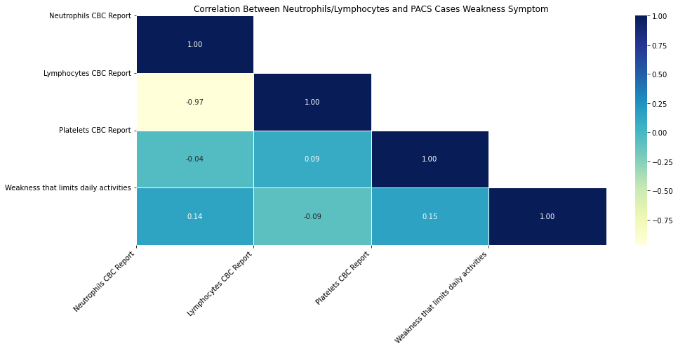
- Association Between Lymphocytes Levels and Fatigue:
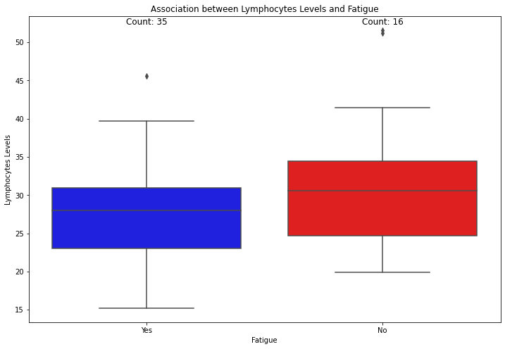
- Association Between Neutrophils Levels and Fatigue:

